**TRAVEL DATA ANALYSIS RESULTS**

1. Majority of people in dataset are from New Delhi
2. Males are in majority in every state except Jaipur or Bhopal
3. Agra is the most loved tourist destination in India
4. Females are more likely to visit Assam then males
5. People with Master’s degree are more likely to visit Agra then any other tourist destination in India

1. Zurich is most loved tourist destination abroad
2. Females are most likely to visit Paris than any other tourist destination abroad
3. People with bachelors or lower degree are most likely to choose Zurich as tourist destination abroad and people with Master’s degree are most likely to visit Kyiv than any other destination
4. Maximum people who are from Delhi belongs to 27 years of age

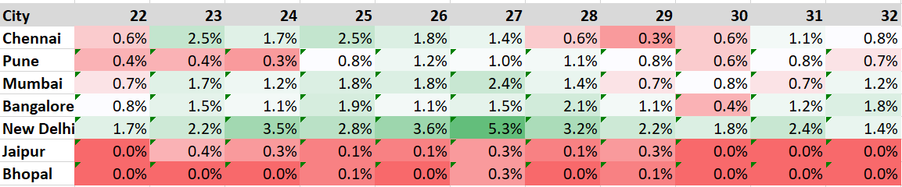

1. People visited Agra are more likely belongs to age group 23 to 27.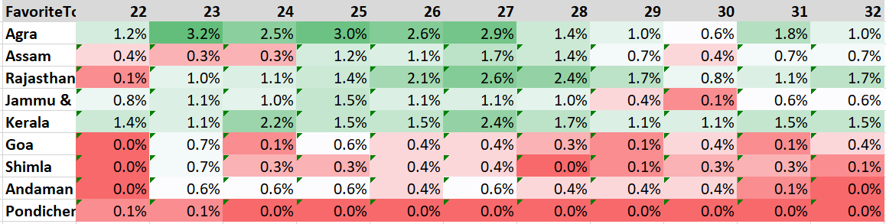
2. People visited Zurich are more likely belongs to age group 23 to 28. 